Functional & Performance Testing Template
ServiceNow Incident Functional and Performance Test

Date | 03 October 2026
Team ID | SWTID-2026-5003
Project Name | Implement Client Script and UI Policy (Incident)
Maximum Marks | Not specified
Team Members and Responsibilities: Kaleeswari G (Team Leader: Milestones 4 and 5, Milestone 6 Activity 1); Devibala. A. S (Milestones 1 to 3); Karthika. M (Milestone 6 Activities 2 to 4); Amirtha Varshini S (Milestone 6 Activity 5 and conclusion).

Test Scenarios & Results
Test Case ID | Scenario (What to test) | Test Steps (How to test) | Expected Result | Actual Result | Pass/Fail
FT-01 | High Impact UI Policy | Open an Incident; set Impact to High. | Policy actions apply: Assignment group mandatory and Urgency read-only. | Screenshots show configuration and form behavior; formal result not recorded. | Not recorded
FT-02 | Urgency onChange behavior | Change Impact to High on an Incident form. | Urgency is set to value 1 and the configured information message appears. | Script configuration screenshot supplied; formal result not recorded. | Not recorded
FT-03 | Assigned To save validation | Set Impact to High; leave Assigned To blank; submit. | Submission is blocked with field-level validation feedback. | Form screenshot shows validation feedback; formal result not recorded. | Not recorded
FT-04 | State list-edit restriction | Attempt direct State edit from Incident list. | The alert appears and the list edit is rejected. | List and alert screenshots supplied; formal result not recorded. | Not recorded
PT-01 | Incident form response time | Measure form load and response after changing Impact on the target instance. | Record baseline and target-instance timings; no threshold supplied. | Not measured in supplied project materials. | Not recorded
PT-02 | Client interaction latency | Measure the response to onChange, policy evaluation, and submit validation. | Record repeatable timing results in the target instance. | No timing or performance log supplied. | Not recorded
PT-03 | Concurrent user behavior | Repeat the defined Incident workflow with representative concurrent users in a test instance. | Record completion rate, errors, and response times; no load target supplied. | No load or concurrency test supplied. | Not recorded

Project Evidence Screenshots
These screenshots document the configured rules and selected form/list states. They are not a formal performance measurement or signed UAT result.
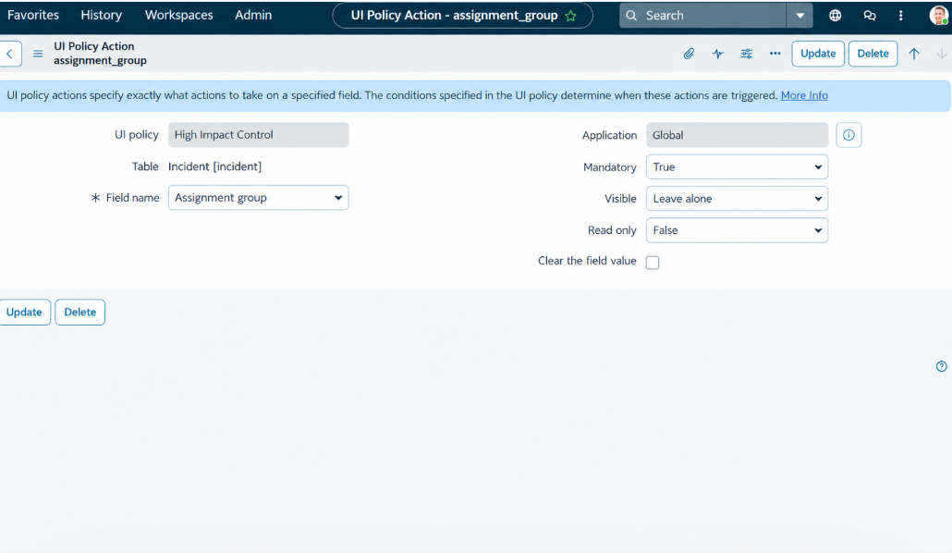
High Impact Control UI Policy
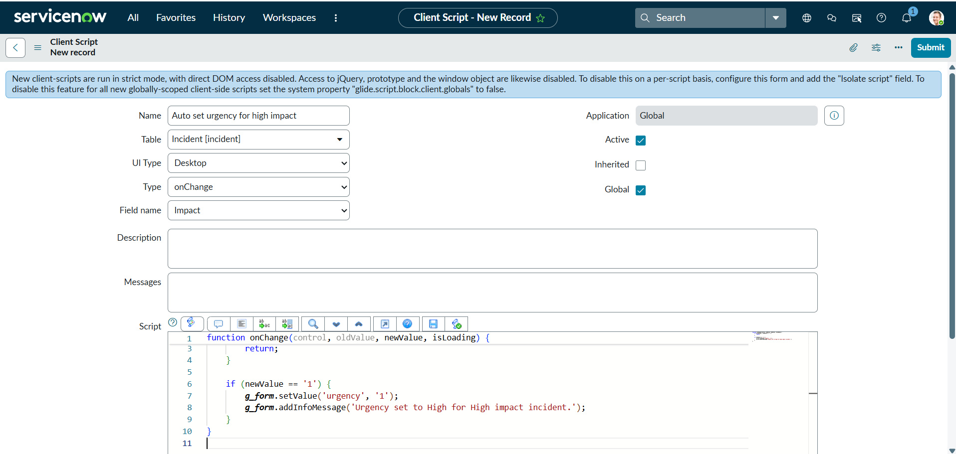
onChange urgency script
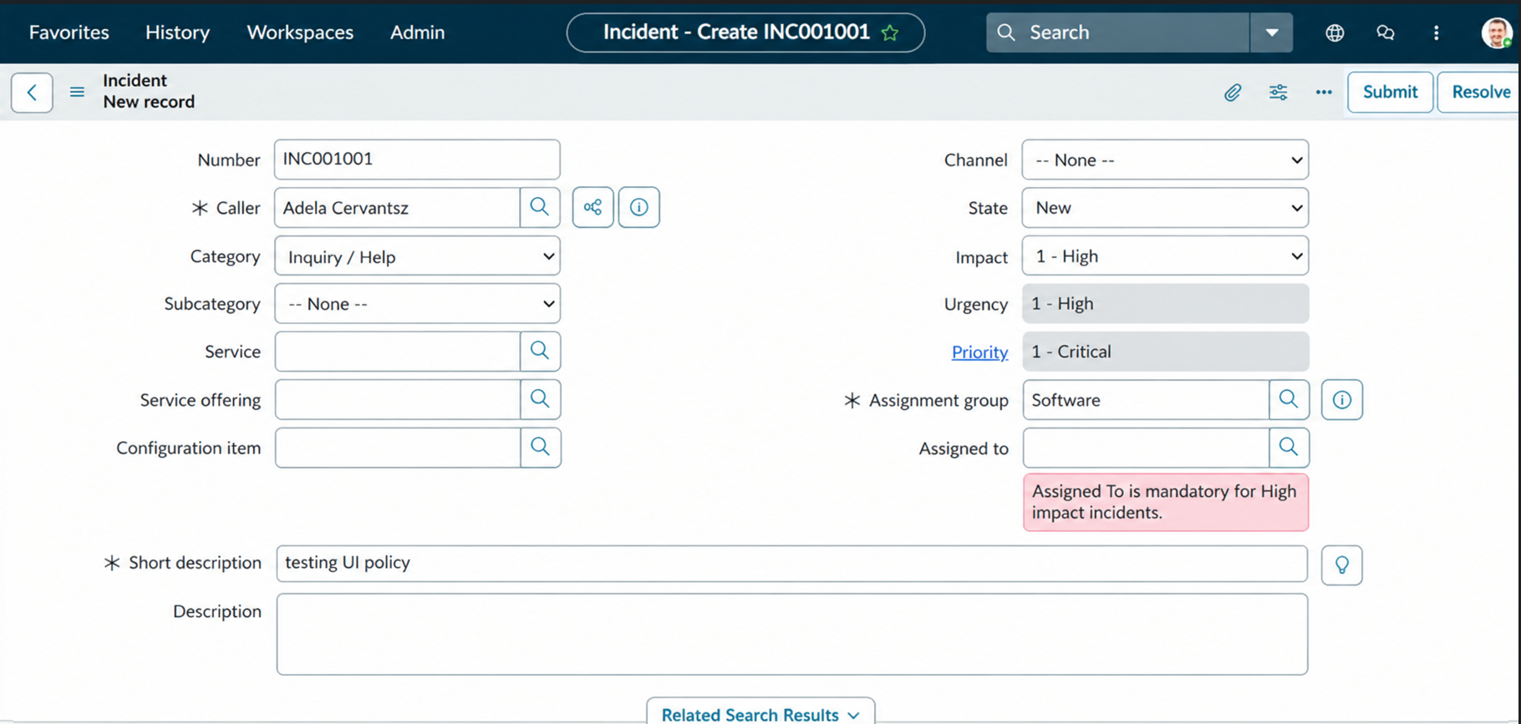
Incident form validation evidence
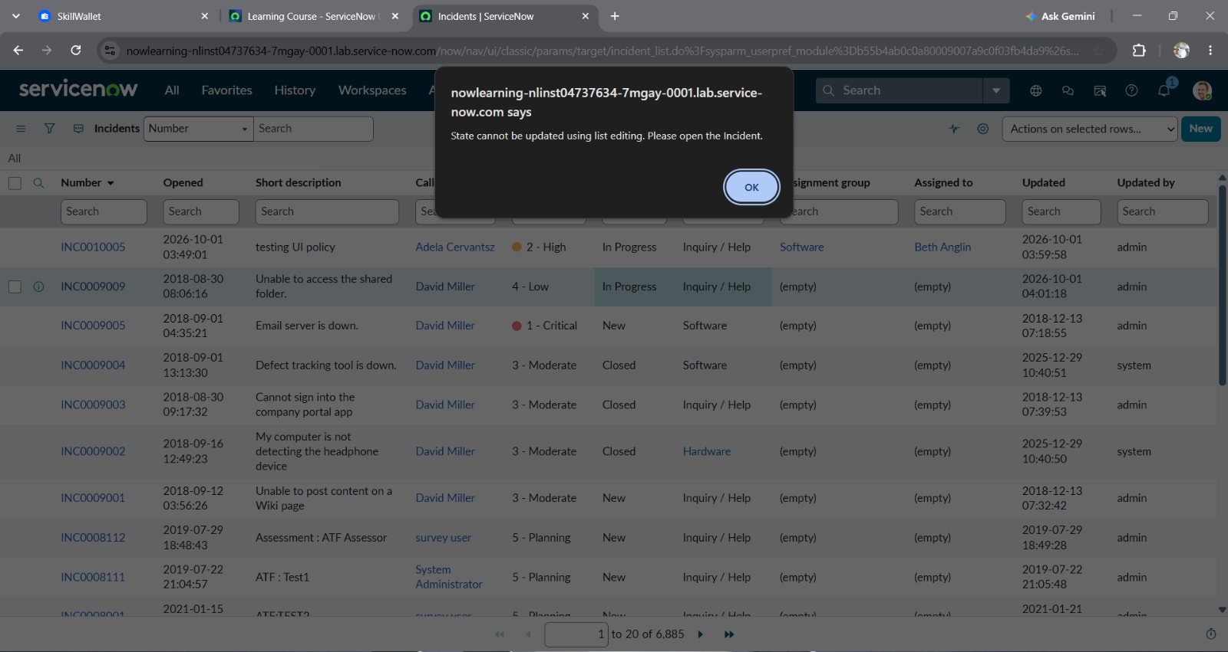
State list-edit alert

